Data Driven Analysis and Prediction of Diabetes using Supervised Learning Models
Harshil Gupta
B. tech (Computer Engineering with Data Science),
Jss University
Period of Internship: 21st January 2026 – 17th February 2026
Report submitted to: IDEAS – Institute of Data- Engineering, Analytics and Science Foundation, ISI Kolkata

Abstract
Diabetes is a chronic disease that affects millions of people worldwide and require early diagnosis to prevent severe complications. In this project, we use diabetes dataset to build machine learning models that can predict whether the person is likely to be diabetes or not.
The dataset contains health related information such as BMI, glucose, insulin and age. first, Data is analyzed to understand its patterns and important features. Then, data preprocessing steps like missing handling models and scaling are applied. Different machine learning algorithms like Logistic Regression and Random Forest
are used to train the model. The dataset is divided into training and testing sets to check the model’s performance. Accuracy and other evaluation metrics are used to measure how the model works. This result shows the machine learning can predicting diabetes and support early medical diagnostics.

Introduction
Diabetes is a chronic metabolic disease caused by high blood sugar (glucose) levels in your blood due to not enough insulin production or the body's inability to use insulin properly. Early diagnosis increases the likelihood of successfully treating individuals for diabetes and reduces the potential for future complications such as cardiovascular disease (heart attacks), kidney failure, nerve damage, and impaired vision.

Because of the increase in technology in today’s world and the development of predictive models, healthcare professionals can now develop predictive models that can determine which individuals may be at risk of developing diabetes by utilizing the diabetes dataset associated with this project. Some examples of the medical predictor variables that the diabetes dataset contains are
(1) Number of pregnancies
(2) Glucose levels,
(3) Blood pressure
(4) Skin thickness
(5) Insulin levels
(6) Body mass index (BMI)
(7) Diabetes pedigree function
(8) Age.
Each of these items is indicative of the presence or absence of diabetes.

Project Objective
The primary focus of this project is to analyze the diabetes dataset to develop a predictive model for determining whether or not a person is diabetic based on information from the medical predictor variables provided. The predictive model being developed will use classification-based machine learning algorithms so that healthcare professionals can easily understand the results of these predictive models and be able to apply them to their patients.
The specific objectives of the project are as follows:
1. Data Understanding and Exploration

- To understand the structure, features, and distribution of data.
- To explore relationships between medical parameters and diabetes results.
- To recognize patterns, correlations, and possible issues in data
2. Data Preprocessing
- To handle missing or zero values appropriately.
- To normalize or standardize data features as needed.
- To prepare data for effective model training.
3. Model Development
- To apply supervised machine learning algorithms, e.g., Logistic Regression, Decision Tree, and Random Forest.
- To train a model using a training dataset.
4. Model Evaluation
- To evaluate model performance using metrics like Accuracy, Precision, Recall, and F1-score.
- To evaluate different models and choose the best model
5. Feature Importance Analysis
- To recognize key factors contributing to diabetes prediction results.
- To improve understanding of results for better comprehension of health risks.
Methodology
The methodology adopted for this project follows a structured and systematic approach to machine learning to ensure accurate prediction of diabetes outcomes. The entire process has been divided into various phases, ranging from data acquisition to model building, evaluation, and interpretation. Each phase has been designed to enhance the reliability, accuracy, and interpretability of the model.
Basically, the data provides about of 768 rows and 9 columns.
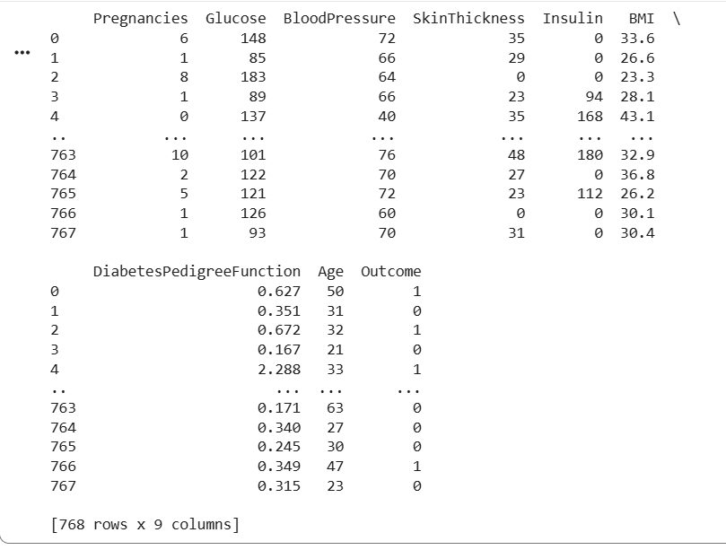

After checking the data, there are several key columns which tells about the diabetic controls.
Then, we segregate the value into major columns and form another table (summary table)
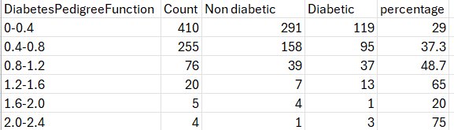

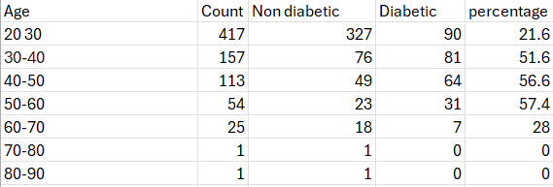
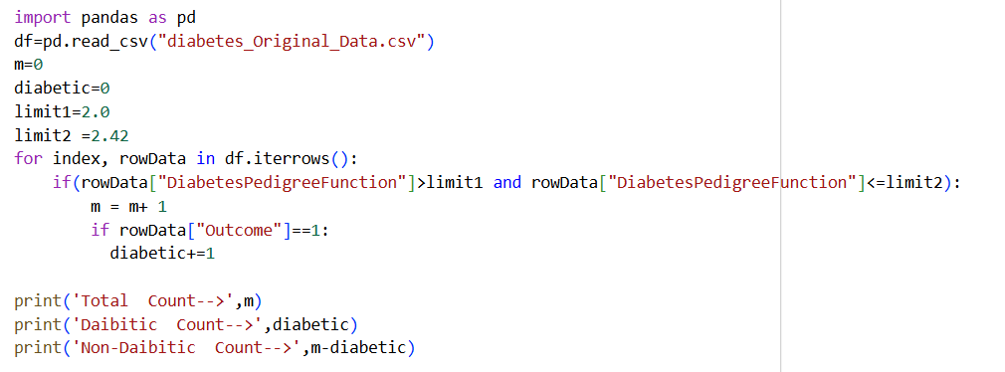

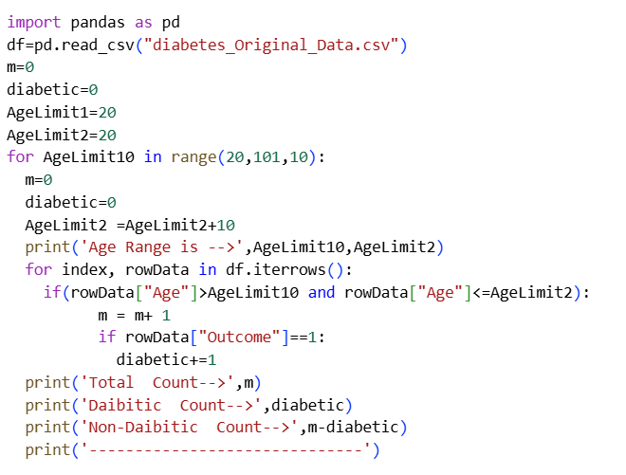

The project methodology followed a systematic process consisting of data collection, data preprocessing, exploratory data analysis, model development, and evaluation.
Step 1: Data Loading – The dataset was imported into Python using the Pandas library.

Step 2: Data Cleaning – Missing values and invalid zero entries were handled appropriately.
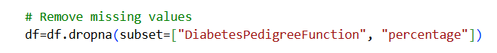
Step 3: Exploratory Data Analysis – Statistical summaries and visualizations such as histograms and scatter plots were generated.
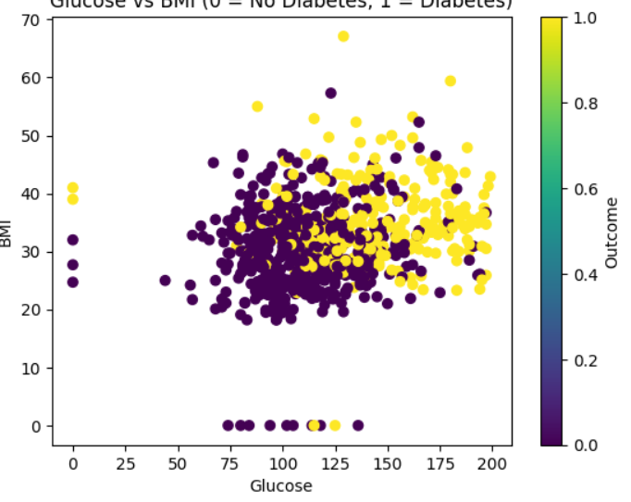

Step 4: Feature Selection – Significant variables such as Glucose, BMI, Age, and DiabetesPedigreeFunction were identified.
Step 5: Train-Test Split – The dataset was divided into training (80%) and testing (20%) sets.
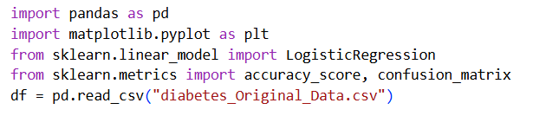

Step 6: Model Development – Logistic Regression was implemented using Scikit-learn.
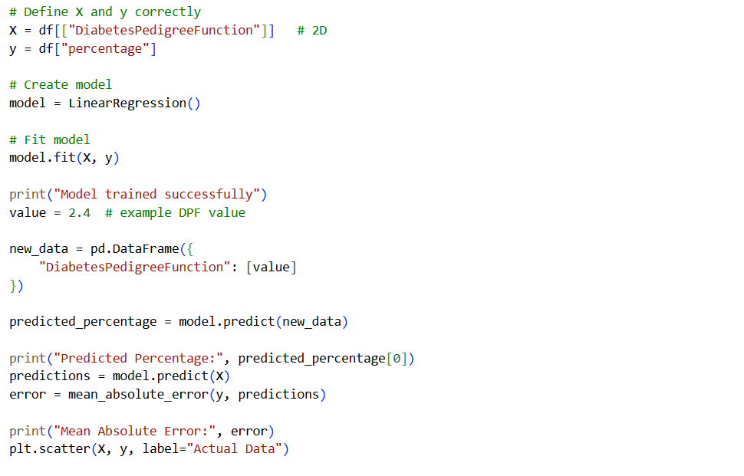
Step 7: Model Evaluation – Accuracy score and classification metrics were calculated to assess performance.
Linear Regression
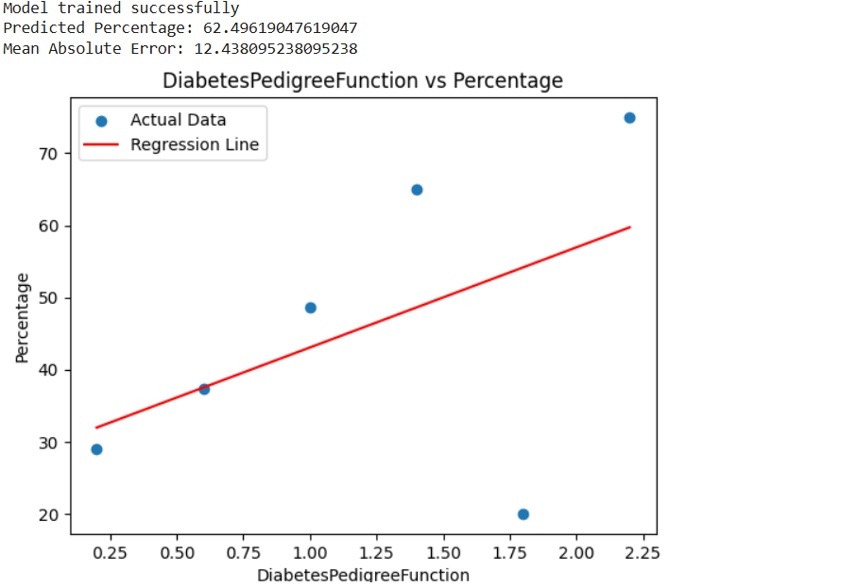

2) Logistic regression
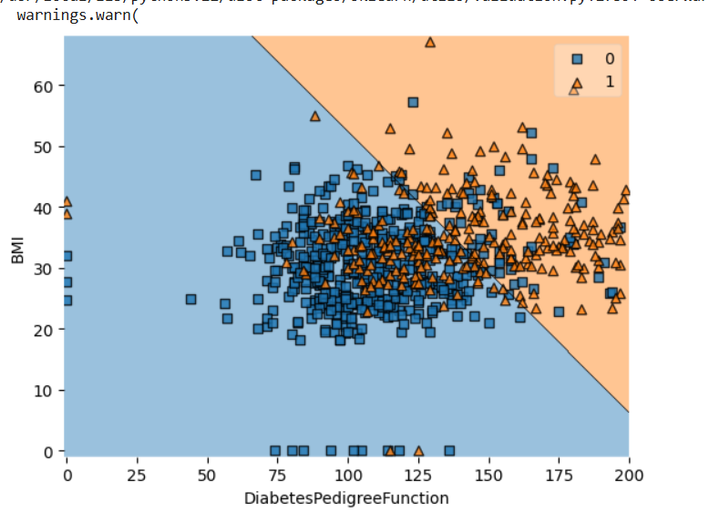

Data Analysis and Results

- The descriptive analysis showed that there is a strong positive association between glucose levels and diabetes.
- BMI and Age have a positive association with the outcome of diabetes.
- Scatter plots showed that there is a clear distinction between diabetic and non-diabetic patients based on glucose levels.
- The Logistic Regression model performed well in terms of predictive accuracy (about 70-80%), ensuring good performance in initial-level medical screening.

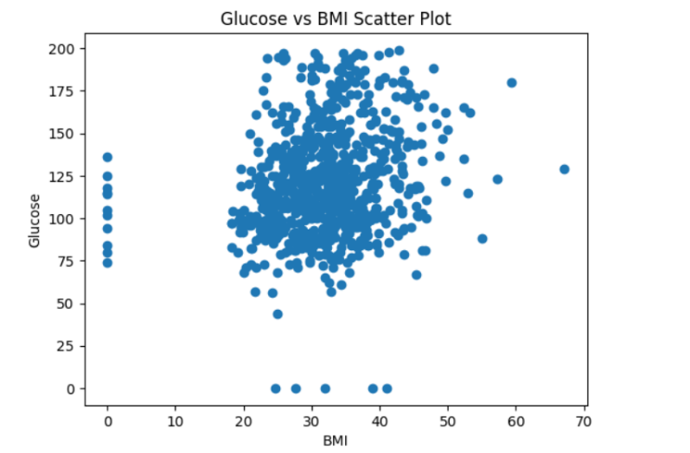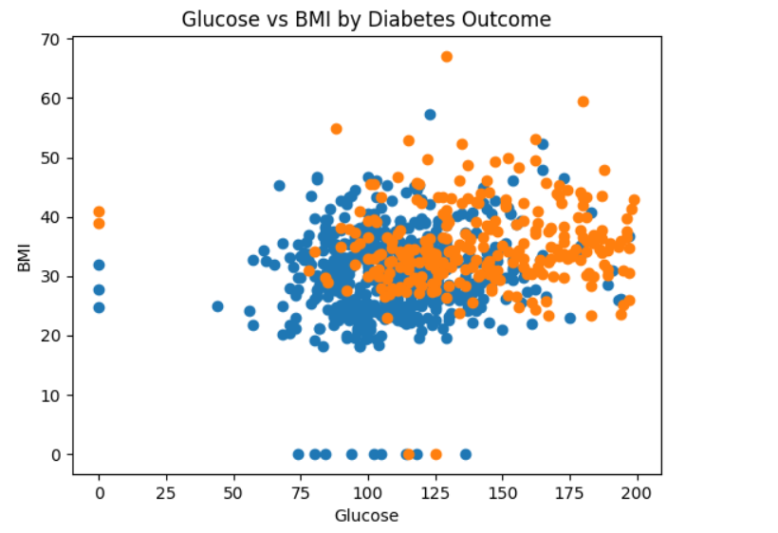
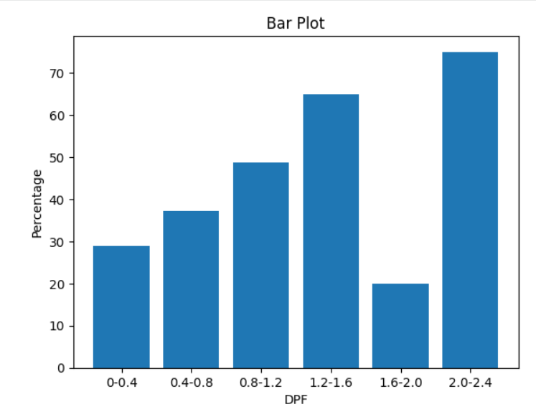
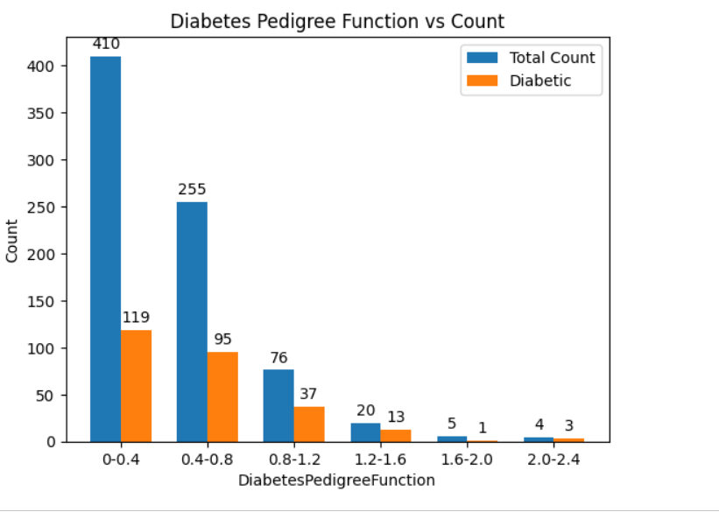

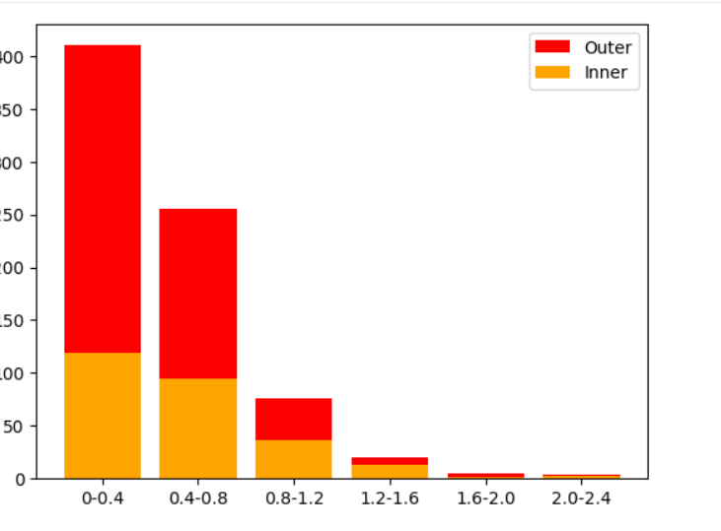
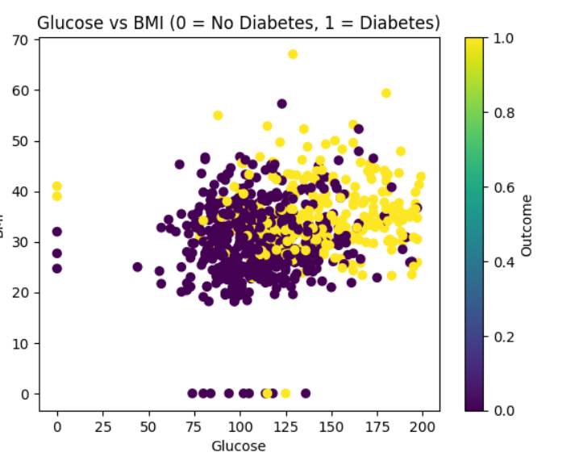
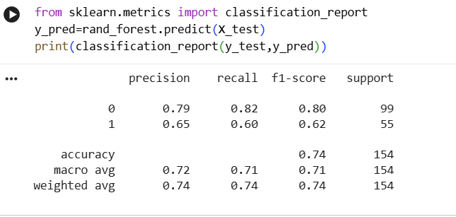

Conclusion
The project is successful in showing the application of machine learning in the field of healthcare analytics. Among all the features, glucose level has been identified as the most significant predictor of diabetes. The proposed model is able to make predictions with a reasonable level of accuracy and can be used for early diagnosis. Future work can be done by using more advanced algorithms such as Random Forest or Logistic Regression.

Appendix
1. Wikipedia, Quora, Blogs
2. Survey Questionnaire
Section 1: Biodata Information
- Age: __________
- Gender:
Male
Female
Other
- Height (in cm): __________
- Weight (in kg): __________

Section 2: Medical History
- Have you ever been diagnosed with diabetes?
Yes
No
- Do you have a family history of diabetes?
Yes
No
- Do you suffer from high blood pressure?
Yes
No
- Do you experience frequent urination?
Yes
No
- Do you often feel excessive thirst?
Yes
No
10.Have you experienced unexplained weight loss recently?
Yes
No
3. https://github.com/harshilguptahgs2007-ux/Project_IDEAS_Details_codes.git

